Cell Phone Policy

- From 8:45 – 3:08, cell phones, electronic devices, air pods, and earbuds are off and in students’ backpacks.
- Cell phones may be used before school or after 3:08.

Consequences
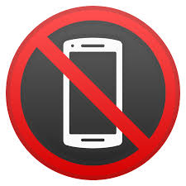

First offense: Phone turned into the front office for student to pick up after school.

Second offense: Phone turned into the front office for parent to pick up. Detention assigned.

Third offense: Loss of phone privilege on campus for one trimester. Detention assigned.

